Mendota 30”-36”-40"-48” Portable Lifeguard Chair
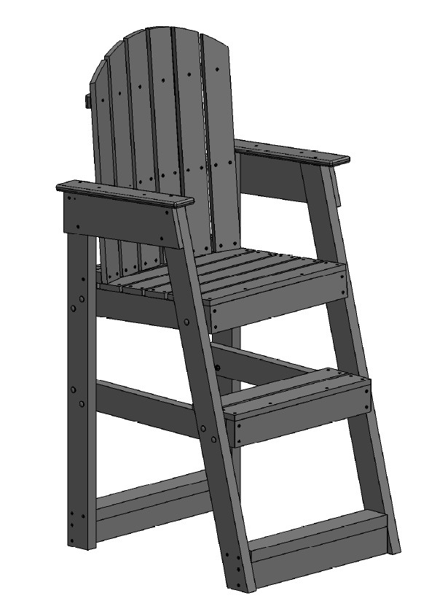
7100 Spectrum Lane | Missoula MT 59808 | 800.791.8056 | www.spectrumproducts.com

You have purchased a Spectrum Products Mendota lifeguard chair. Providing the unit is assembled correctly and properly maintained, it will furnish you with many years of trouble free use. It is important to read this entire manual prior to assembly or operation.

Tools Required:
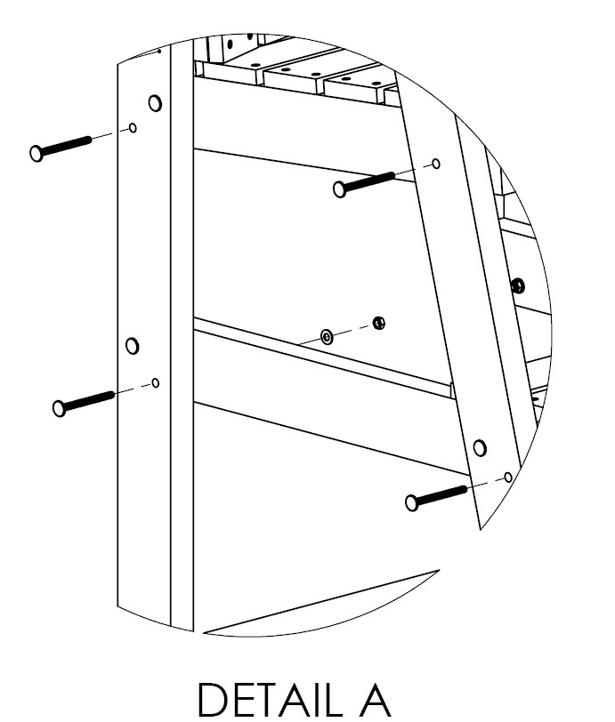
Quad Head Bit
1/2” Open End Wrench
1/2” Socket and Ratchet
Mallet
- Assemble Main frame together as shown on one side in Detail A, making sure to leave hardware loose, using:
8 x 5/16” x 3 ½” Carriage bolts
8 x 5/16” Lock Washers
8 x 5/16” Hex Nut
*Note: Set up the chair on a flat surface, this will make installation of hardware much simpler.
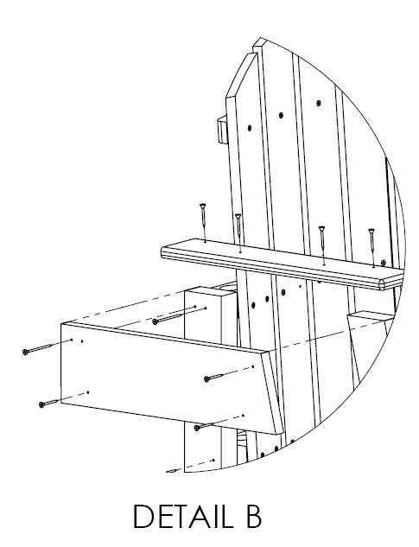
*Note: Set the heads of the carriage bolts into the HDPE lumber with the mallet before tightening; do not over tighten the hex nuts.
Armrest Stiffener

- As Shown in Detail B Screw together the armrest stiffener (both sides) making sure to screw into the existing holes, using:
8 x 1 ½” Quad Head Screws.
*Note: It is important not to over tighten the stainless-steel screws, this leaves a depression in the surface where water and contaminates can build up.
- Tighten all hardware from step 1
- As shown in Detail C, attach seat back to seat bottom (please use existing holes) using:
3 x 1 ½” Quad Head Screws
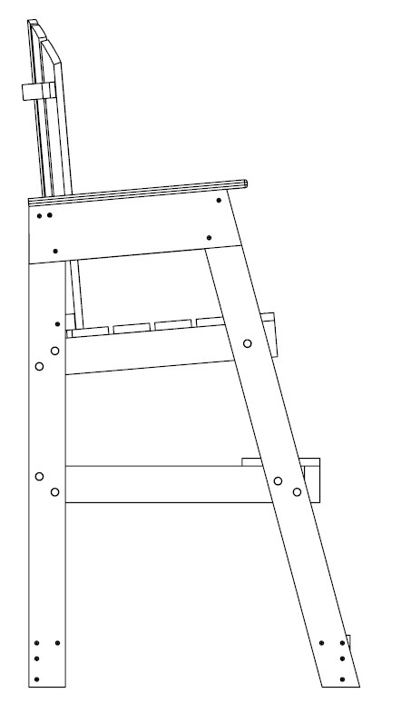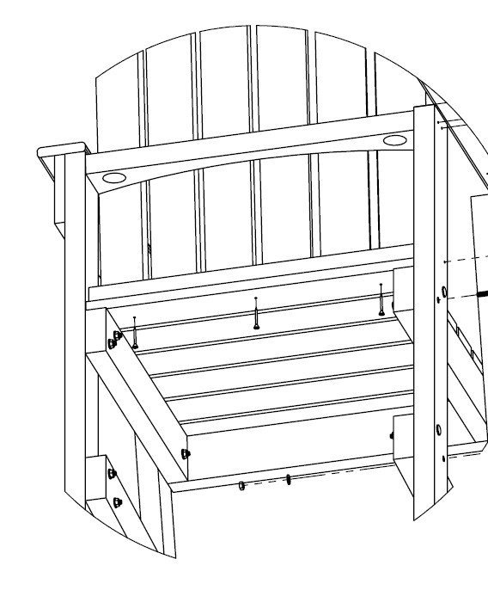
DETAIL D
DETAIL C

1
½” Quad Head Screws

2
½” Quad Head
Screws

- Attach the seat back as shown in Detail D making sure to screw into existing holes, using:
  - x 2 ½” Quad Head Screws
- Then attach armrest as shown in Detail E using:

4 x 1 ½” Quad Head Screws
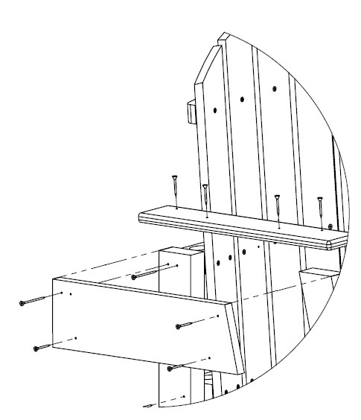
DETAIL E

- If applicable, attach wheels as shown using the hardware shown below. Ensure that all hardware is snug but not over-tightened. If it is over-tightened, the wheels will be significantly more difficult to roll.
2 x BOLT CB 5/16"-18x3 1/2" TYPE 316
4 x FLAT WASHER 5/16"
2 x 5/16" NYLOCK NUT
