MENDOTA DUAL STEP

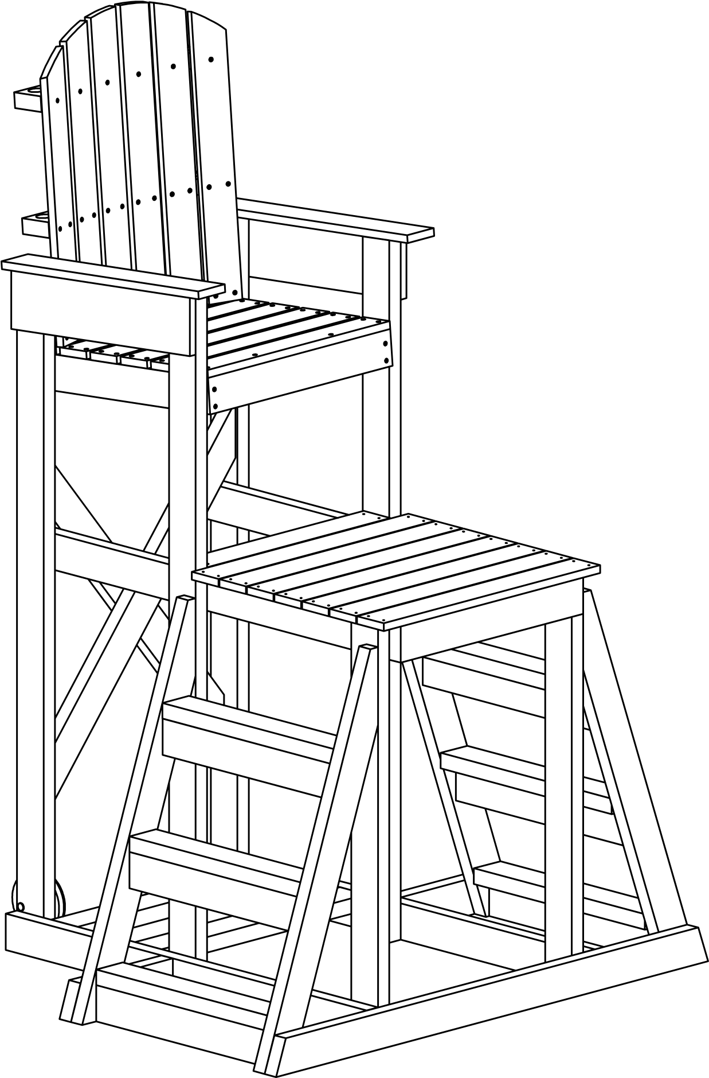



7100 Spectrum Lane | Missoula MT 59808 | 800.791.8056 | www.spectrumproducts.com
Mendota Dual Step Assembly:
Tools Required;
Drill with Square Drive Bit
1/2" Open End Wrench
1/2" Socket and Ratchet Mallet
Hardware Pack Includes;
(22) 2 1/2" Square Drive Screws
(18) 1 1/2" Square Drive Screws
(26) 5/8" Carriage Bolts
(26) 5/8" Hex Nuts
Note:
- All carriage bolts to be left loose until stated otherwise.
Set up chair on a flat surface, this will make the installation of the hardware much simpler.
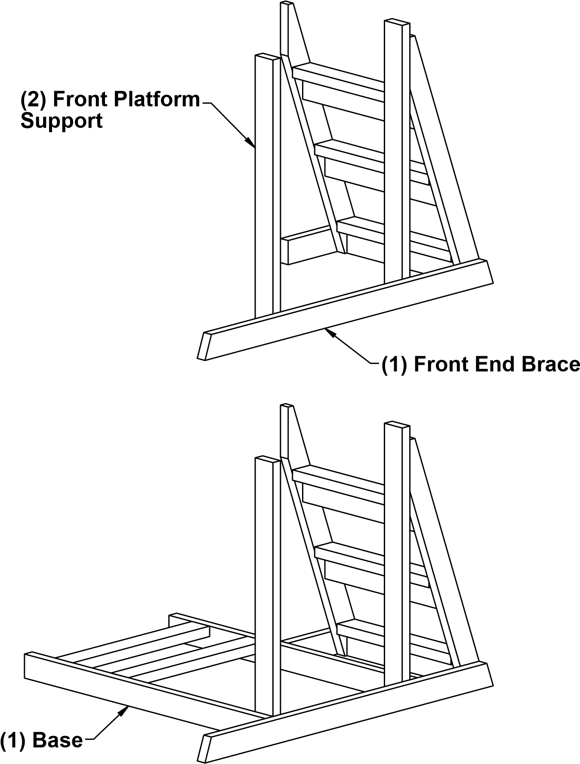
- Set the heads of the carraige bolts into the HDPE lumber with the mallet beforetightening; DO NOT overtighten the hex nuts.
Step 1:
Using the provided pre-drilled holes attach the Front Platform Support to the Front End Brace with; (4) 2 1/2" Square Drive Screws.
Step 2:
Attach the base with;
(2) Carriage Bolts
(2) Hex Nuts
Note - do not tighten hardware leave loose until stated otherwise
Step 3:
Place Lower Back as shown. Attach with;
(2) Carriage Bolts
(2) Hex Nuts
Step 4:
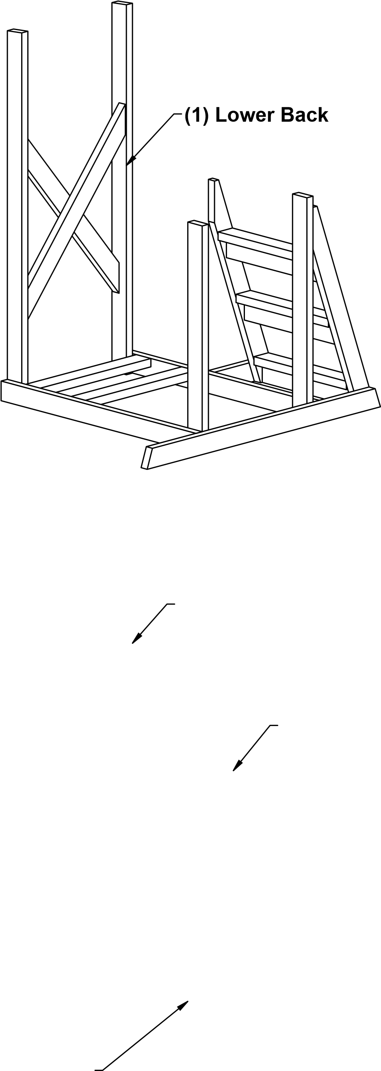
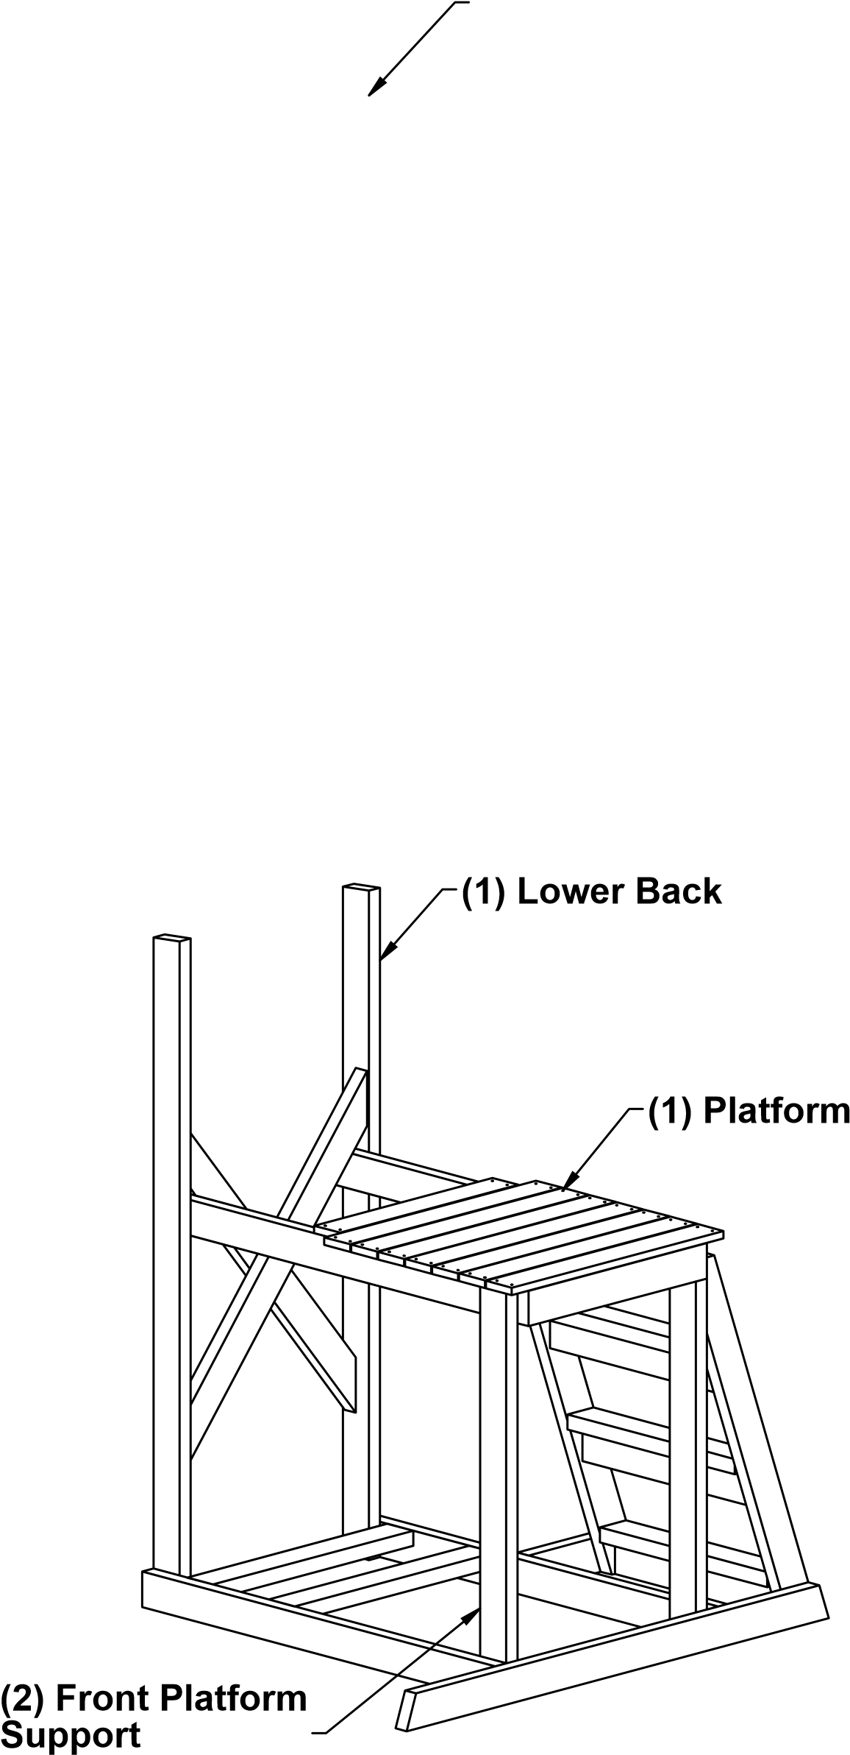
Attach the Platform to Front Platform
Support with;
(2) Carriage Bolts
(2) Hex Nuts
Swing Foot Rest up to meet Lower
Back. Attach with;
(4) Carriage Bolts
(4) Hex Nuts
Add screw to Platform and Front Platform Support using pre drilled holes.
(2) 2 1/2" Square Drive Screws
Step 5:
Place Arm Supports as shown. Attachment at Base uses;
(2) Carriage Bolts
(2) Hex Nuts
Attachment to Platform uses;
(4) Carriage Bolts
(4) Hex Nuts

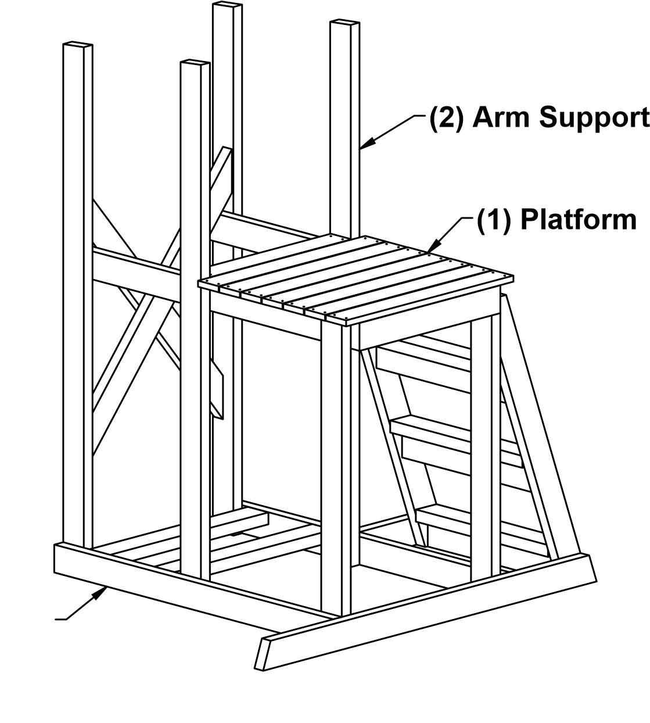
- Base
Step 6:
Attach Seat to Arm Support using;
- Carriage Bolts
(2) Hex Nuts
Swing Foot Rest up to meet Lower
Back. Attach with;
(4) Carriage Bolts
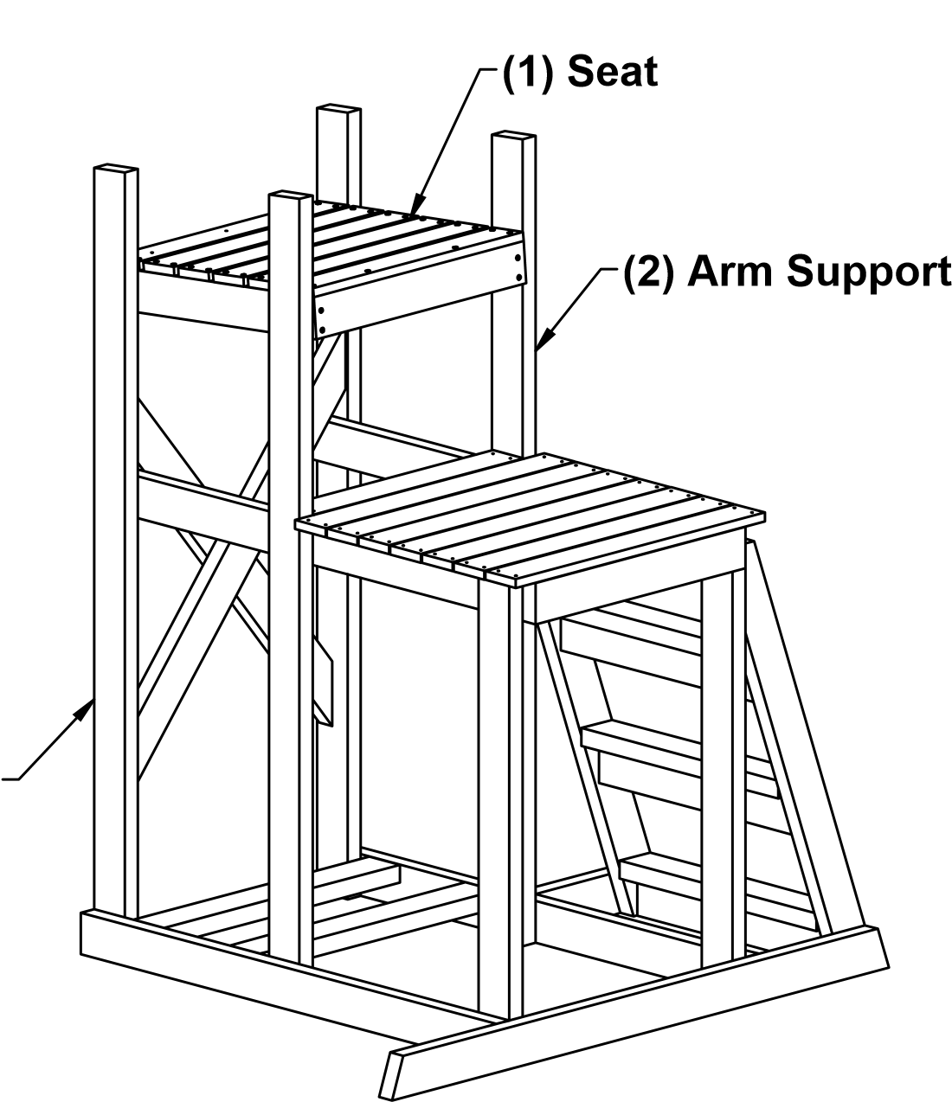
(4) Hex Nuts
- Lower Back
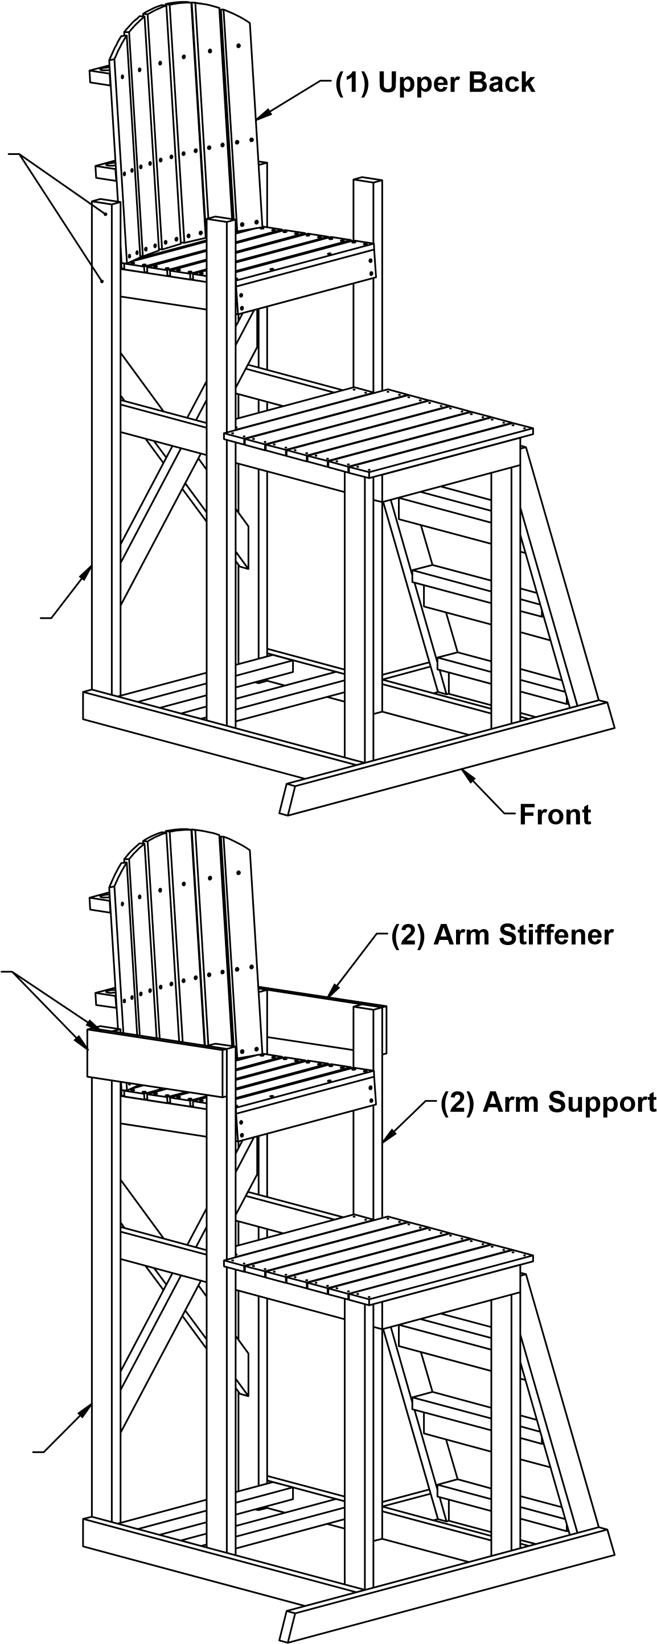
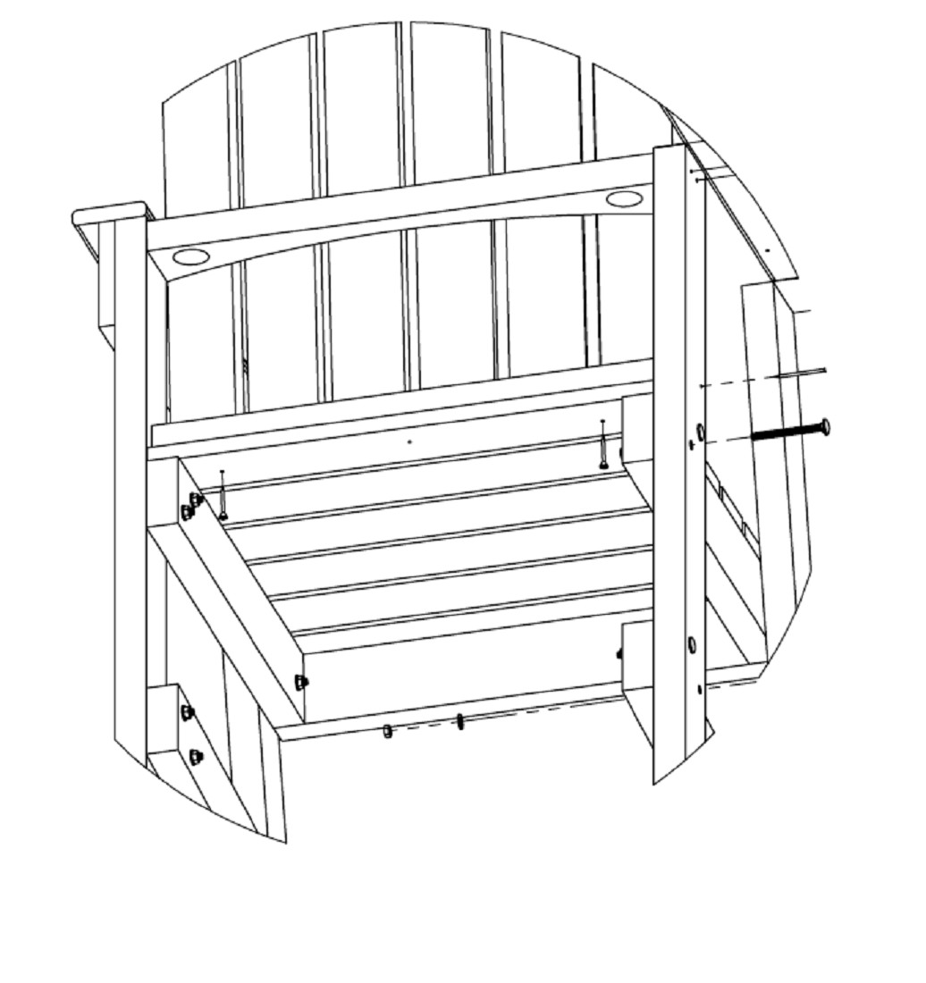
Use these pre-drilled holes. On top two holes use front hole
Step 7:
Attach Upper Back to Seat as Shown Below;
- 1 1/2" Square Drive Screws
Attachment to Lower Back using;
(4) 2 1/2" Square Drive Screws
(1) Lower Back
Flush top and side Step 8:
Attach Arm Stiffener to Lower Back. Use provided pre drilled holes;
(4) 1 1/2" Square Drive Screws
Note: Insure Arm Stiffener is flush to Lower Back top and side.
Flush front of Arm Stiffener to Arm Support than attach with;
(4) 1 1/2" Square Drive Screws
(1) Lower Back Step 7:
Tighten all hardware. DO NOT overtighten hex nuts.
Step 9:
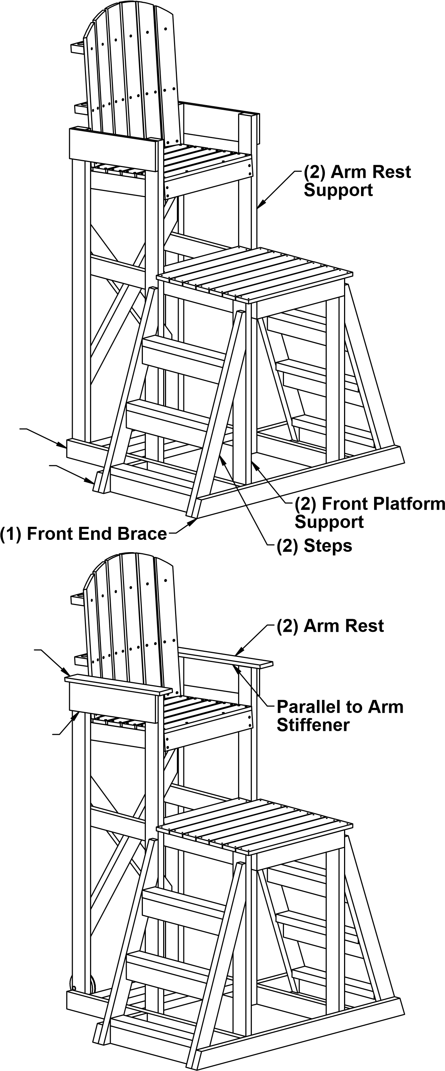
Place Step Supports as shown. Attach to Base using;
(4) 2 1/2" Square Drive Screws
Attach Steps to Step Supports and
Front End Brace with;
(4) Carriage Bolts
(4) Hex Nuts
Attach Steps to Front Platform Support and Arm Support with provided pre drilled holes using;
(8) 2 1/2" Square Drive Screws
  - Base
  - Step Support
Flush to rear of Lower Back
(2) Arm Stiffener Step 10:
Attach Arm Rest to Arm Stiffener.
Use provided pre drilled holes and;
(8) 1 1/2" Square Drive Screws
Note: Insure Arm Rest parallel to Arm Stiffener and Flush to the rear of the Lower Back.
Step 11:
Attach Wheels using;
(2) Bolt CB 5/16"-18x3 1/2"
(4) Flat Washer 5/16"
(2) 5/16" Nylock Nut
