Mendota 48” & 60"
Portable Lifeguard Chair
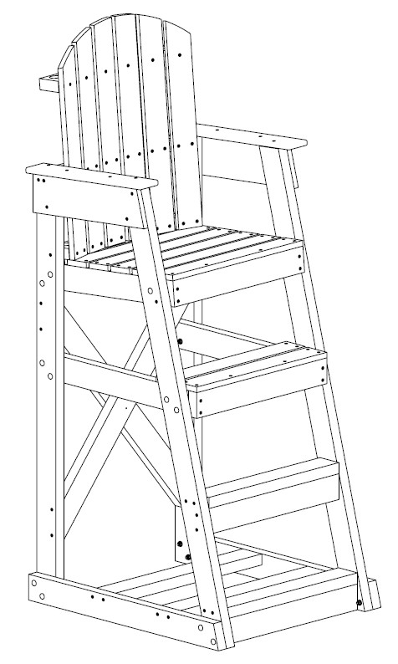


7100 Spectrum Lane | Missoula MT 59808 | 800.791.8056 | www.spectrumproducts.com
Tools Required:

Drill with Quad Head Bit
1/2” Open End Wrench
1/2” Socket and Ratchet
Mallet

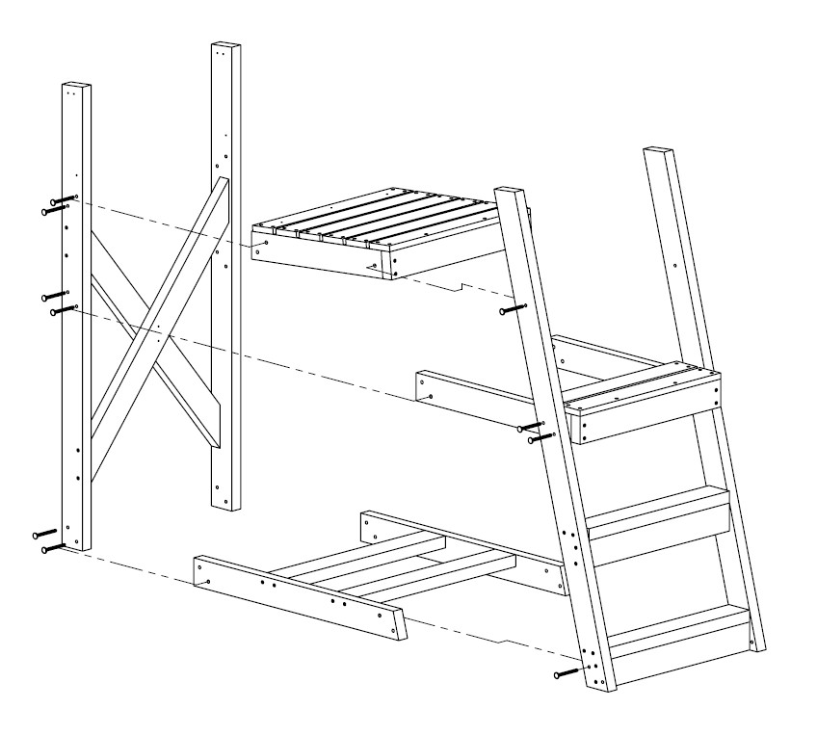

DETAIL A | No bolt necessary on this model as shown here

- Assemble main frame together as shown on one side in Detail A, making sure to leave hardware loose, using:

5/16” x 3 ½” Carriage bolts
5/16” Lock Washers 5/16” Hex Nuts

*Note: Set up the chair on a flat surface, this will make installation of hardware much simpler.

*Note: Set the heads of the carriage bolts into the HDPE lumber with the mallet before tightening; do not over tighten the hex nuts.

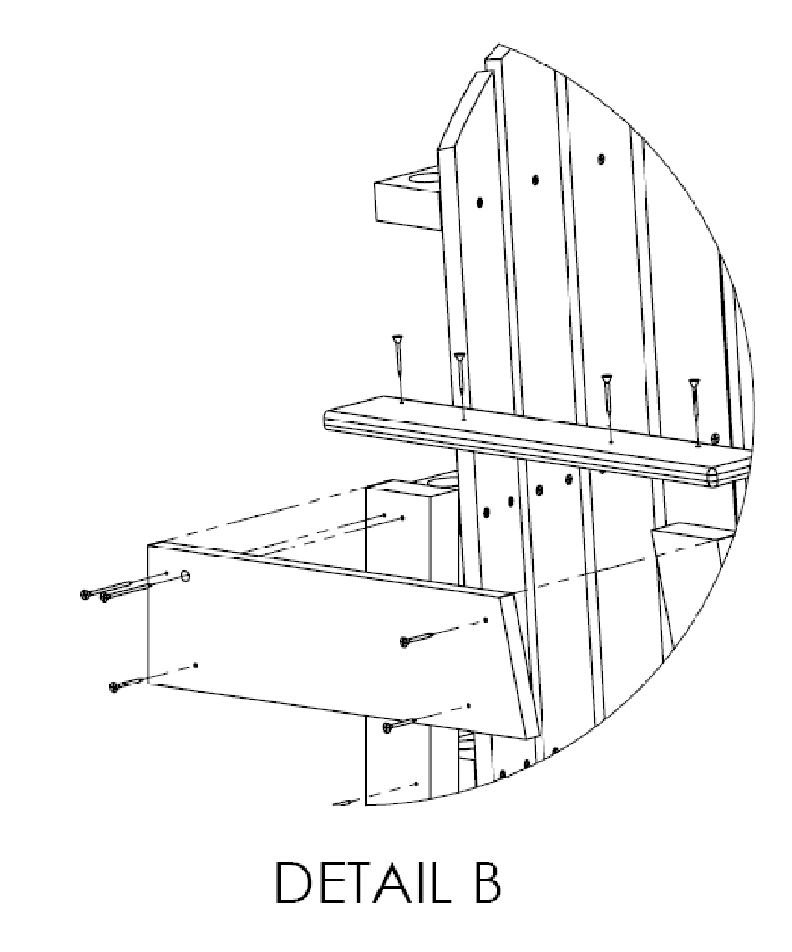
- As shown in Detail B, screw together the armrest stiffener (both sides) making sure to screw into the existing holes, using:

Armrest Stiffener

8 - 1 1/2" Quad Head Screws

*Note: It is important not to over tighten the stainless steel screws, this leaves a depression in the surface where water and contaminates can build up.

- Tighten all hardware from step 1

- As shown in Detail C, attach seat back to seat bottom (please use existing holes) using:

2 – 1 1/2" Quad Head Screws

2 1/2" Quad
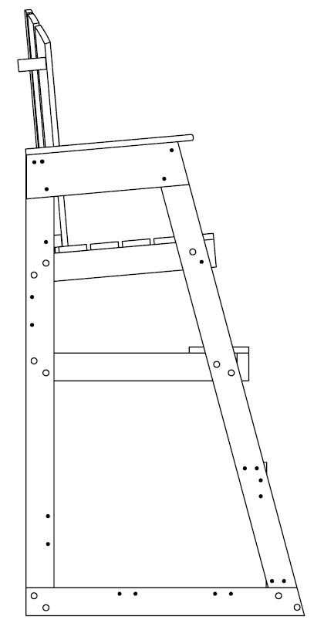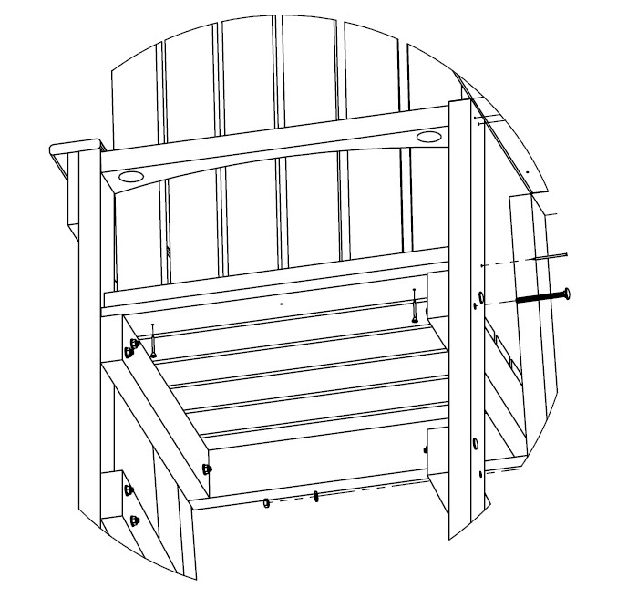

1
½”
Quad Head
Screws

Head Screws

DETAIL D DETAIL C

- Attach the seat back as shown in Detail D making sure to screw into existing holes, using:

  - – 2 ½” Quad Head Screws

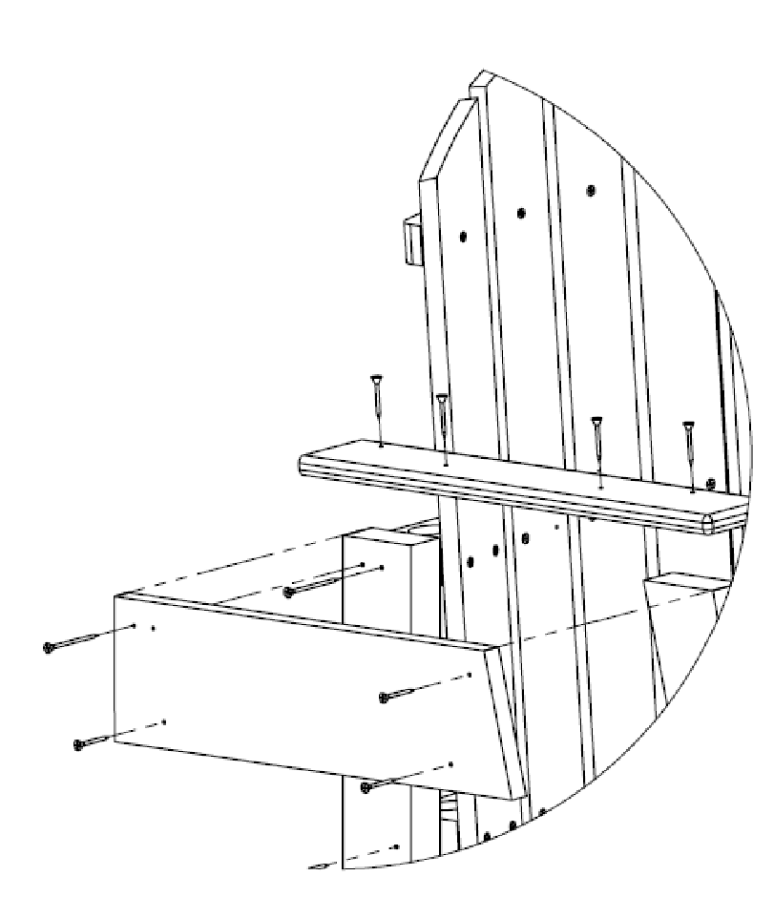
- Then attach armrest as shown in Detail E using:

  - –1 ½” Quad Head Screws

DETAIL E

- For 60" Mendota Slide Base Support in as shown;

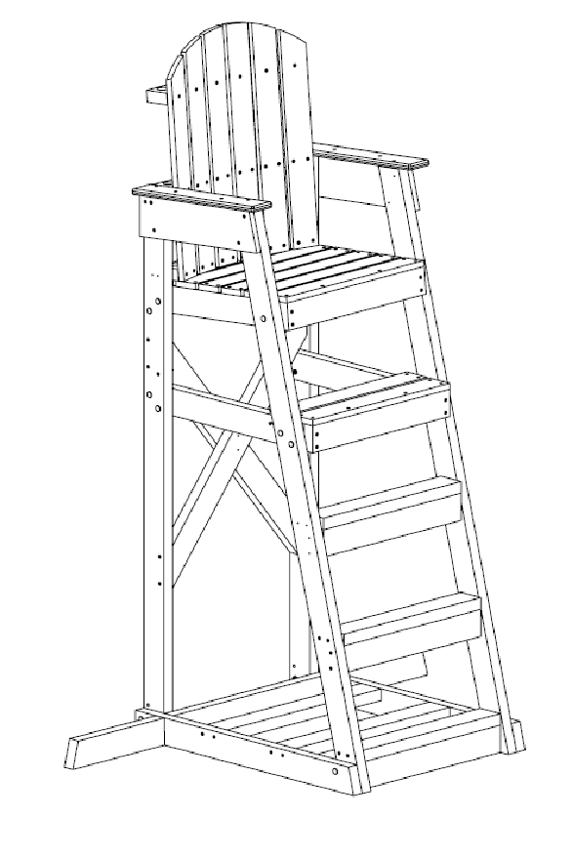

- Attach wheels as shown using;

2 - BOLT CB 5/16"-18x3 1/2" TYPE 316
4 - FLAT WASHER 5/16"
2 - 5/16" NYLOCK NUT

